***Intro Page***

**Lamb Boulevard, Clark County & City of Las Vegas**

The Nevada Department of Transportation (NDOT) developed a Safety Management Plan to evaluate and improve safety on Lamb Boulevard between E. Desert Inn Road and Lake Mead Boulevard in Clark County. As part of the plan, existing roadway safety, usage and accessibility will be evaluated. Proposed improvements will enhance safety, mobility and connectivity, so pedestrians, bicycles and vehicles can all safely share the road. The recommended safety improvements could be implemented in future years as funding becomes available. To learn more about the recommended safety improvements and the SMP process, please check out the Lamb Boulevard Safety Management Plan.

***Main Page***

**Lamb Boulevards Safety Management Plan**

The Lamb Boulevard Safety Management Plan (SMP) is a transportation planning effort that focuses on traffic safety for all road users, incorporating corridor studies, access management, public and stakeholder input, crash analysis, roadway engineering, and application of the Highway Safety Manual (HSM) methods to reduce roadway crashes. The SMP process is consistent with the Nevada Strategic Highway Safety Plan’s overall goals of significantly reducing the number and severity of roadway crashes in the state.

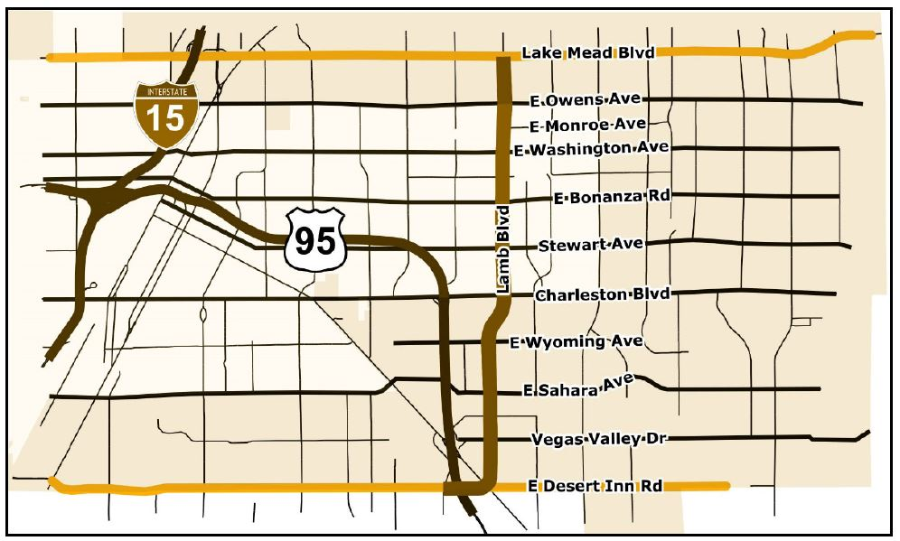

*Study Area: Lamb Boulevard from East Desert Inn Road, north to East Lake Mead Boulevard*

Project Documents

* Lamb Boulevard SMP – Final Report

Public Meeting Tuesday, December 5, 2017

* Lamb Boulevard SMP – Boards
* Lamb Boulevard SMP – Presentation
* Lamb Boulevard SMP – Handout

**McCarren Boulevard Safety Management Plan**

The purpose of a Safety Management Plan (SMP) is to conduct a safety-focused corridor study concentrated towards all road users and to include collaboration with stakeholders and the public. A SMP includes the development of short, mid, and long-range transportation safety improvement projects that incorporate traffic studies, access management, crash analyses, benefit-cost analysis, public and stakeholder input, and other impacts to all road users. The SMP process is consistent with the Nevada Strategic Highway Safety Plan’s overall goals of zero fatalities and reducing serious injuries on Nevada’s roadways.

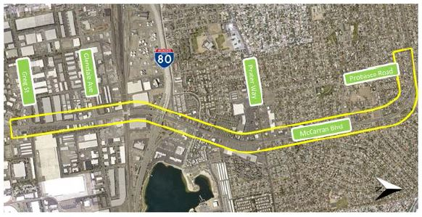

*Project Study Area of McCarren Boulevard SMP Corridor*

Project Documents

* McCarren Boulevard SMP – Final Report
* McCarren Boulevard SMP - Appendix

Public Meeting Tuesday, December 5, 2017

* McCarren Boulevard SMP – Boards
* McCarren Boulevard SMP – Presentation
* McCarren Boulevard SMP – Handout