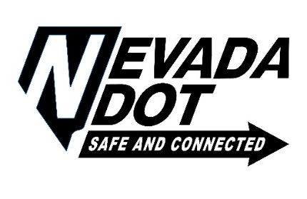 **Department of Transportation**

**Board of Directors**

**Notice of Public Meeting**

**1263 South Stewart Street**

**Third Floor Conference Room**

**Carson City, Nevada**

**January 31, 2019 – 9:00 a.m.**

AGENDA

1. Public Comment – limited to no more than three (3) minutes. The public may comment on Agenda items prior to action by submitting a request to speak to the Chairman before the Meeting begins. *Informational item only.*
2. Consideration of Appointment of new Director to the Department. Pursuant to Nevada revised statute 408.106 consideration of the selection of Kristina L. Swallow as the Director of the Nevada Department of Transportation – *For possible action.*

3. Public Comment – limited to no more than three (3) minutes. *Informational item only.*

4. Adjournment – *For possible action.*

**Notes:**

* Items on the agenda may be taken out of order.
* The Board may combine two or more agenda items for consideration
* The Board may remove an item from the agenda or delay discussion relating to an item on the agenda at any time.
* Reasonable efforts will be made to assist and accommodate physically handicapped persons desiring to attend the meeting. Requests for auxiliary aids or services to assist individuals with disabilities or limited English proficiency should be made with as much advance notice as possible to the Department of Transportation at (775) 888-7440.
* This meeting is also expected to be available via video-conferencing, but is at least available via teleconferencing, at the Nevada Department of Transportation District One Office located at 123 East Washington, Las Vegas, Nevada in the Conference Room and at the District III Office located at 1951 Idaho Street, Elko, Nevada.
* Copies of non-confidential supporting materials provided to the Board are available upon request.
* Request for such supporting materials should be made to the Department of Transportation at (775) 888-7440. Such supporting material is available at 1263 South Stewart Street, Carson City, Nevada 89712 and if available on-line, at www.nevadadot.com.

This agenda was posted at www.nevadadot.com and at the following locations:

Nevada Dept. of Transportation Nevada Dept. of Transportation Nevada Dept. of Transportation

1263 South Stewart Street 123 East Washington 310 Galletti Way

Carson City, Nevada Las Vegas, Nevada Sparks, Nevada

Nevada Dept. of Transportation Governor’s Office

1951 Idaho Street Capitol Building

Elko, Nevada Carson City, Nevada