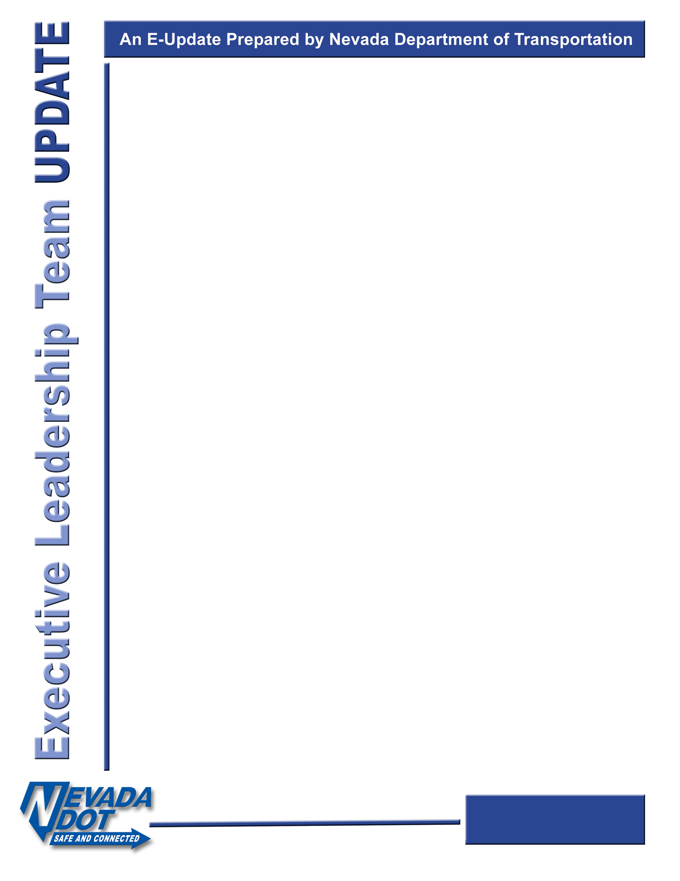

**Schools & Families Encourage Activity**

***Nevada Moves Day***

Keeping Nevadans safe on our roadways is our Team’s highest goal, especially when it comes to our *most vulnerable road users*. Teaching children about pedestrian and bicycle safety is one of the very best tools we have in achieving that goal.

March is designated as **Nevada Moves Month**.

Schoolchildren across the state are encouraged to take part **in safe walk or bicycle to school activities** all month and specifically on **Nevada Moves Day, held March 18**.

This is an excellent way to inspire families to change up their daily routine of driving to and from school drop-off and pick up and incorporate walking or bicycling to school instead! Nevada Moves Day provides the opportunity to learn valuable lessons about bike and pedestrian safety as a family or through organized school events.

Walking and bicycling events are planned at schools in Carson City, Clark, Washoe, Lyon and many other counties across Nevada. Children who are not taking part in an organized school activity are encouraged to get their families involved by safely walking or bicycling to school together on **Nevada Moves Day**. Moving together on this special day could even inspire more family outings throughout the year.

Although this day is set aside primarily to highlight safety, the importance of overall physical activity is also recognized. Being physically active reduces heart disease, diabetes and other obesity-related illnesses. Not to mention, when we get out of the car and set out on foot or bike for even just a day, we lessen traffic around schools and positively impact the environment.

*How can you as a NDOT team member support this day? Be a walking volunteer, please contact our Safe Routes to School Coordinator, Cathy Balcon at* [*cbalcon@dot.nv.gov*](mailto:cbalcon@dot.nv.gov) *or ext. 7357*

Happy Moving!

***Kristina***

***#superproud #TeamNDOT***

Please remember that this and all previous Director’s Updates can be found on our [Sharepoint](https://nevadadot.sharepoint.com/sites/002/Shared%20Documents/Forms/Default.aspx?RootFolder=%2Fsites%2F002%2FShared%20Documents%2FDirector%27s%20Updates&FolderCTID=0x012000632AD58F7724AF4FB0C07A2207624B6C&View=%7BC521BF2C%2D7165%2D4241%2DB2D7%2D367067E13440%7D) page.

March 2020