Bicycle Safety Word Search

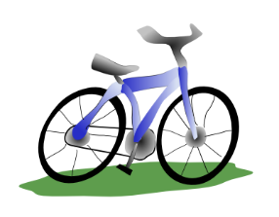

[This Photo](https://humbliceous.blogspot.com/2006/02/blue-bicycle.html) by Unknown Author is licensed under [CC BY-SA](https://creativecommons.org/licenses/by-sa/3.0/)

M G W S V N N U Y Q F X K C N

A Y B B H P H U B C S C H T R

T D I D D Q U O X I P I T A L

H A N D L E B A R S C H A I N

N L Q U C E N A L N A Y Z M W

H H S H W H F L V Q Q S C C J

E S E K A R B S R S O E Z L C

L D K H U L A U L A Z R S L E

M O K R I G H Y S A B I Y U Y

E Q N G O D K R E E D T X M B

T S H M Q N A Y L Z Q E E I I

X T Y M Z E Q L T H G A P D K

S O G N G K V T R L N F W O E

G B M I P M Z S U Z P U D Q Y

D A I E B A J B O I J R Y H E

Find the words below:

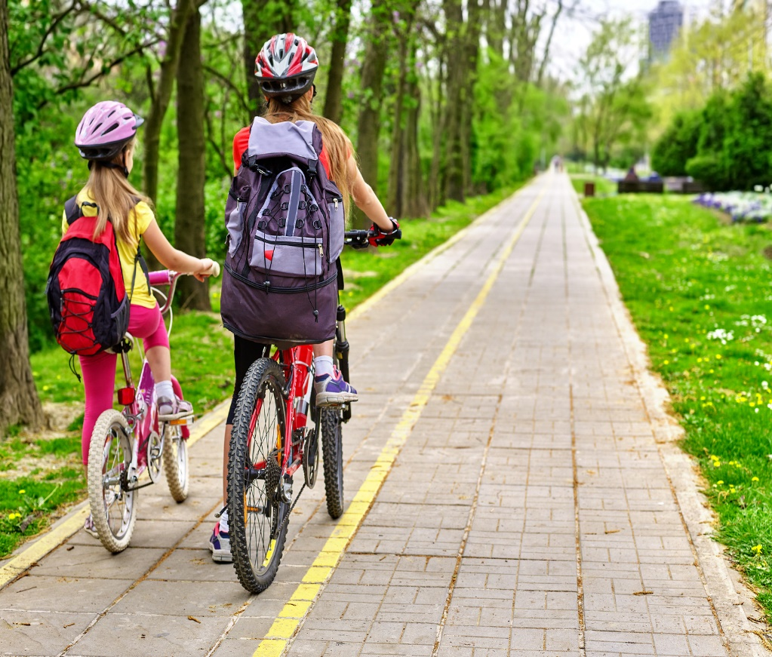

[This Photo](https://www.groundreport.com/bicycle-lanes-evolve-move-away-cars-fewer-accidents/) by Unknown Author is licensed under [CC BY-NC](https://creativecommons.org/licenses/by-nc/3.0/)

BELL

BICYCLE

BIKE

BRAKES

CHAIN

GEARS

HANDLEBARS

HELMET

HORN

LANE

LIGHTS

PEDALS

TIRES