Secure Bid Acceptance Portal

General Information

*Secure Bid Acceptance Help Contacts*

NDOT Contract Services

Phone: (775) 888-7070, Option 2

Email: [ndotcontractservices@dot.state.nv.us](mailto:ndotcontractservices@dot.state.nv.us)

*Secure Bid Acceptance System Requirements*

The iCX application has been tested to run on the following browsers:

* Chrome
* Internet Explorer 9 and higher
* Mozilla/Firefox

*Logging into Secure Bid Acceptance Portal*

No login credentials are needed. Please click on, or copy and paste the following link into a web browser: <https://securebidacceptance.azurewebsites.net/vendor>

*Definitions*

New Bid – the is to be used for the first time a bid submitted on a contract. If a correction needs to be made to that submittal, a Replacement Bid needs to be made (please see Replacement Bid).

Replacement Bid – this is selected when an initial bid has already been submitted but the information submitted needs to be updated or changed. **When selecting this option, all prior documents must be resubmitted.** Staff will not open the prior documents submitted, only the most recent submission date and time submittals will be opened and considered final and complete.

Vendor Name – the name of the company or agency that the contractor/vendor is submitting the bid for.

Overview

*Dashboard*

Once you click on the link or copy and paste the link into a web browser, you will be brought to the following dashboard. The dashboard provides the following general information: contract number, location, when the bid was advertised, which the bid opening date and time are, as well as a navigation option to submit a bid.

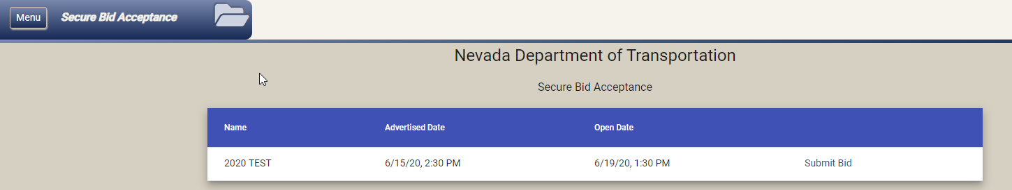

Bidding in Secure Bid Acceptance Portal – New Bid

To bid on a particular contract, select the ‘Submit Bid’

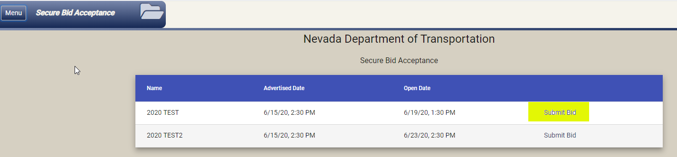

*Completed the Required Fields*

Enter the following required fields:

* Vendor Name
* Submitted by Name
* Email Address – **Note:** ensure accuracy when entering the email information
* Phone

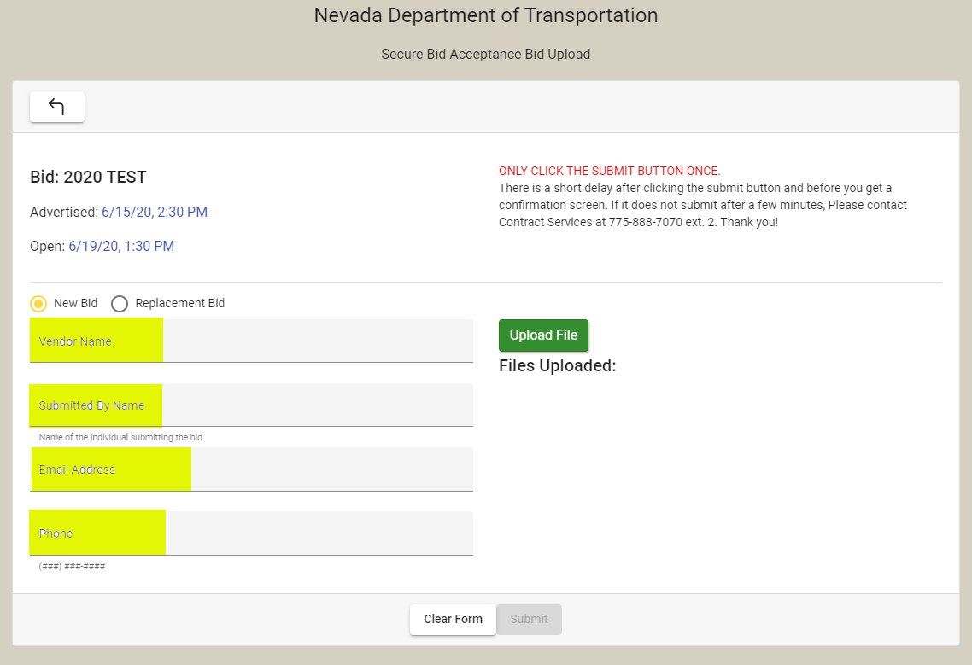

*Uploading and Deleting Documents*

Upload all the required and necessary bidding documents by selecting the ‘Upload File’ button. If more than one document is being uploaded, you will have to upload each document separately. **Note:** Please name each document as to what it represents.

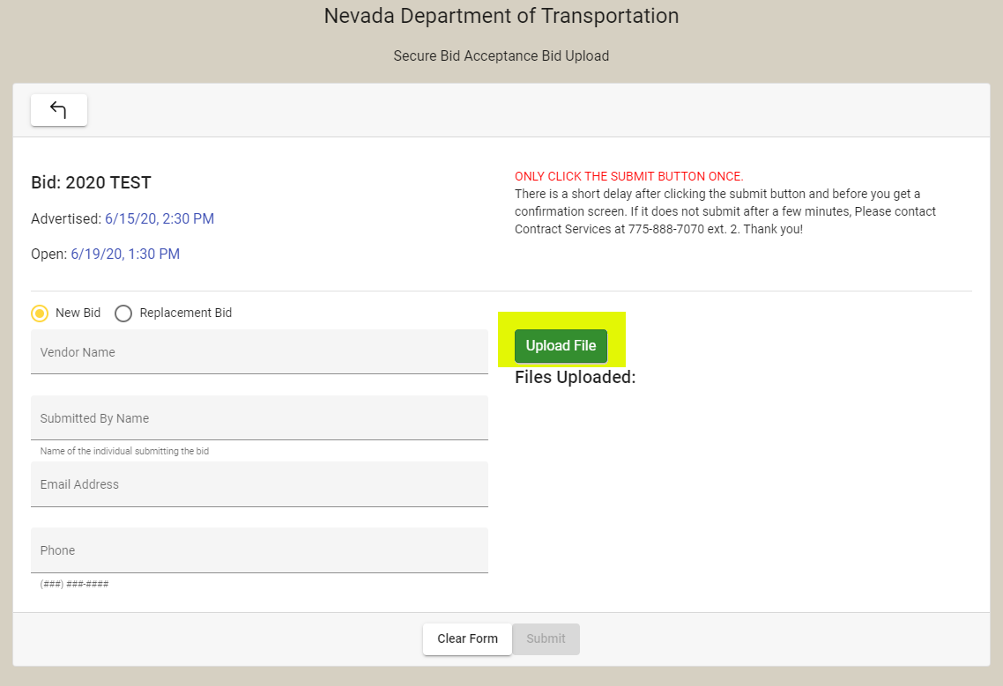

The documents uploaded should appear as well as an option to delete a document. **Note: Once you have submitted your bid you will not be able to alter any part of the submission. To replace or update your bid, you will need to submit a ‘Replacement Bid’ in its entirety. (See page 7)**

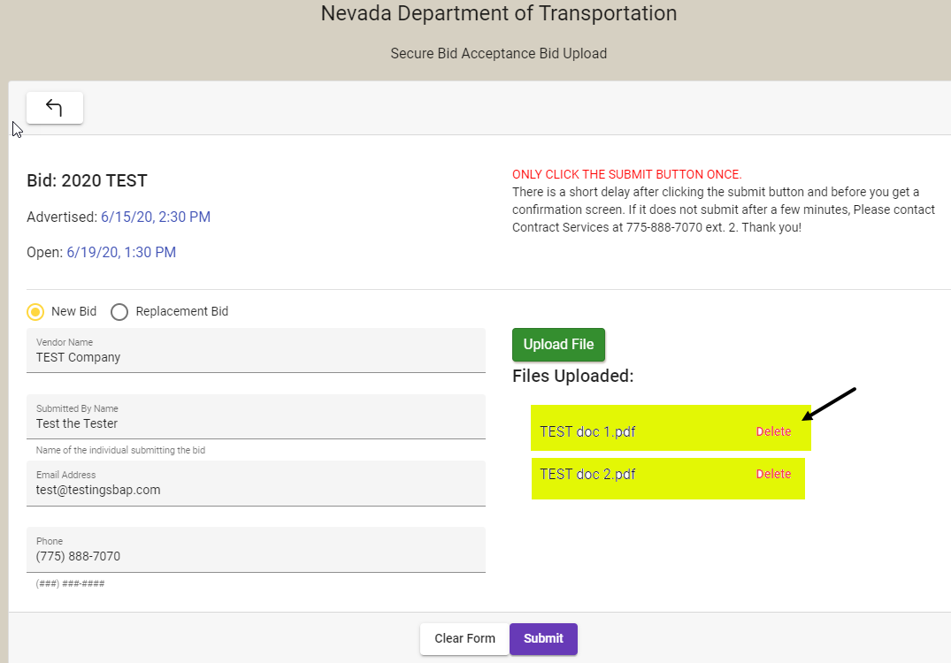

*Submitting*

**Note:** There is a short delay after clicking the submit button and before you receive a confirmation screen of submittal. If it does not submit after a few minutes, please contact Contract Services at 775-888-7070, Option 2

After selecting ‘Submit’ you will receive a confirmation splash screen and a confirmation email. If you do not receive the email, please check your junk email, or call Contract Services at 775-888-7070, Option 2 for confirmation receipt of bid submittal.

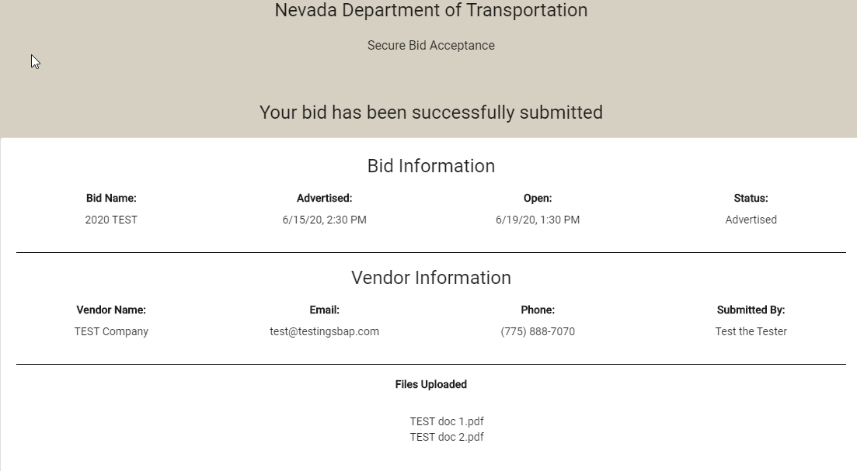

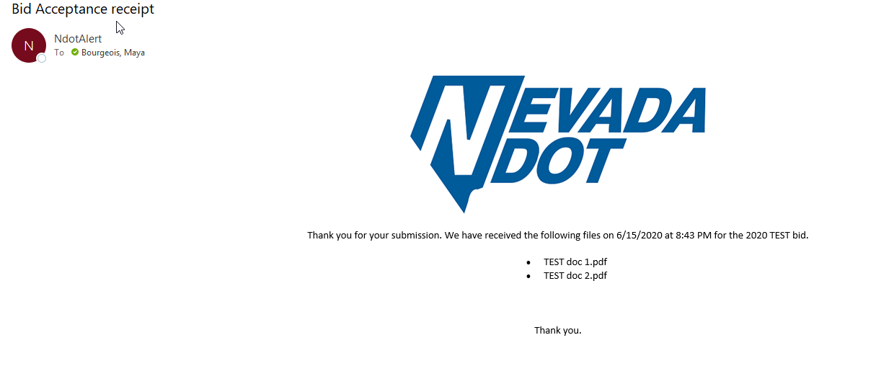

Bidding in Secure Bid Acceptance Portal – Replacement Bid

A Replacement Bid this is selected when an initial bid has already been submitted but the information submitted needs to be updated or changed. **When selecting this option, all prior documents must be resubmitted.** Staff will not open the prior documents submitted, only the most recent submission date and time submittals will be opened and considered final and complete.

To submit a Replacement Bid, from the Dashboard select ‘Submit Bid’ from the specific contract you want to replace the bid for.



*Completed the Required Fields*

Select ‘Replacement Bid’

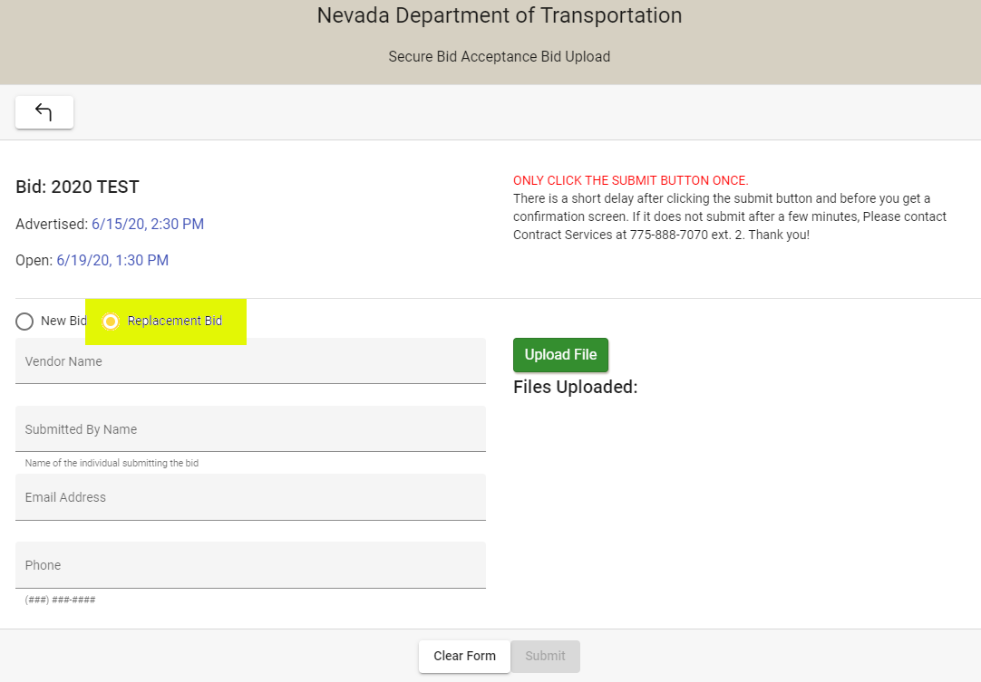

Enter the following required fields:

* Vendor Name
* Submitted by Name
* Email Address – **Note:** ensure accuracy when entering the email information
* Phone



*Uploading and Deleting Documents*

**All prior documents must be resubmitted.** Staff will not open the prior documents submitted, only the most recent submission date and time submittals will be opened and considered final and complete. Upload all the required and necessary bidding documents by selecting the ‘Upload File’ button. If more than one document is being uploaded, you will have to upload each document separately. **Note:** Please name each document as to what it represents.



The documents uploaded should appear as well as an option to delete a document. **Note: Once you have submitted your bid you will not be able to alter any part of the submission. To replace or update your bid, you will need to submit a ‘Replacement Bid’ in its entirety.**



*Submitting*

**Note:** There is a short delay after clicking the submit button and before you receive a confirmation screen of submittal. If it does not submit after a few minutes, please contact Contract Services at 775-888-7070, Option 2

After selecting ‘Submit’ you will receive a confirmation splash screen and a confirmation email. If you do not receive the email, please check your junk email, or call Contract Services at 775-888-7070, Option 2 for confirmation receipt of bid submittal.



