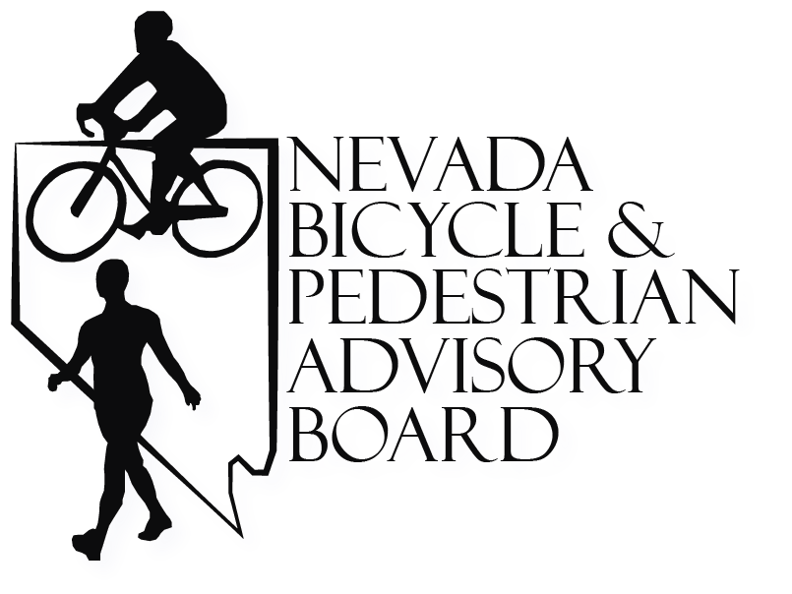 | NOTICE AND AGENDA OF  PUBLIC MEETING  for  NEVADA BICYCLE AND PEDESTRIAN ADVISORY BOARD  (NBPAB)
8:30 A.M., March 18th, 2021

Meeting Location:

Microsoft Teams meeting
Join on your computer or mobile app
Click here to join the meeting
Or call in (audio only)
+1 702-780-6673,,4308353# United States, Las Vegas
Phone Conference ID: 430 835 3#
Find a local number | Reset PIN
Learn More | Meeting options

- Action to call meeting to order

- Roll call of NBPAB members

- PUBLIC COMMENT AND CITIZENS PARTICIPATION:

No action may be taken on any matter discussed under this item that is not listed on this Agenda, although the NBPAB can direct that such items be placed on a future agenda.
At this time, any citizen in the audience may address the NBPAB on any matter. No vote can be taken on a matter not listed on the posted agenda; however, the NBPAB can direct that the matter be placed on a future agenda.

Each citizen must be recognized by the Chairperson. The citizen is then to approach the microphone to state his or her name, and to spell the last name for the record. The Chairperson may limit remarks if such remarks are disruptive to the meeting or not within the NBPAB’s jurisdiction.

The Nevada Department of Transportation keeps the official record of all proceedings of the meeting. To maintain a complete and accurate record, copies of documents used during a presentation must be submitted to the Recording Secretary.

The Nevada Bicycle and Pedestrian Advisory Board appreciates the time citizens devote to be involved in this important process.

Public comment is limited to 5 minutes per person.

Agenda items may be taken out of the order presented on the agenda at the discretion of the chairperson. The Board may combine two or more agenda items for consideration. The Board may remove an item from the agenda or delay discussion relating to an agenda item at any time. The Board may make reasonable restrictions on time, place, and manner but will not restrict the comments based upon viewpoint.

4.
Approval of the September 17th, 2020 and January 21st minutes (for possible
action)

Action may be taken to approve the September 17th, 2020 and January 21st
meeting minutes.

5. Review of “Share the Road” License Plates and Grant Applications
Albert Jacquez (for possible action)
The NBPAB developed a “Share the Road” specialty license plate to provide additional funding for local bicycle and pedestrian initiatives throughout the state. Funds are made available through a competitive grant process administered by the NDOT. All proposed projects must not exceed more than $2,000.00 and be focused on safety education concerning one or more of the following criteria:

- Initiation, promotion, and support of bicycle and pedestrian safety and education programs in Nevada
- Financial support of the planning and construction of bicycle and pedestrian facilities in Nevada
- Grants for community-based bicycle and pedestrian projects and programs in Nevada
- Bicycle and pedestrian safety outreach

A review of all application received will be given.

6. Update on Trails, Transportation and Tourism Summit Scott Bohemier
The Trails Transportation and Tourism Summit is an annual meeting focused on
issues affecting bicyclists and pedestrians. an update on the planning of the next
summit will be given

7. Tahoe Transportation Initiatives TTD representative

One Tahoe is an initiative to complete funding on a long-awaited extensive
transportation system envisioned by the community that will enhance the traveling
experience (choices of transit, bike/pedestrian trails, auto, water borne) throughout
the greater Lake Tahoe Region while protecting Lake Tahoe’s distinctive natural
beauty.

8. 2021 Legislative Session Update Alan Bohemier (for possible
action)
An update will be provided on the introduction of Senate Bill SB 183. If this bill passes as written, it will prohibit persons from riding
bicycles, electric bicycles, and electric scooters on a roadway with a posted speed
limit of 65 miles per hour or more. Action may be taken to provide advisement
to
agencies in relation to this bill.

9. Reports from the Bicycle and Pedestrian Programs Statewide

An update of projects and initiatives being worked on by the NDOT and the
Washoe County and Clark County Metropolitan Planning Areas will be given.

10. Board Member Reports
Reports will be provided from NBPAB members on activities, initiatives, or issues
specific to their sectors occurring since the last meeting on January 21st, 2021.

11. Schedule and prepare items to be placed on the next agenda (for possible
action)
The next NBPAB meeting is proposed to be scheduled for May 20th, 2021.
Items of interest to NBPAB may be agenized for a future meeting, including items
mentioned during the Board Member Reports. Action may be taken to change the
next meeting date and time.

12. PUBLIC COMMENT (with restrictions as set forth in Agenda Item No. 3)

13. Adjournment (for possible action)

Accessibility: Reasonable efforts will be made to assist and accommodate physically handicapped persons desiring to attend the meeting. Request for auxiliary aids or services to assist individuals with disabilities should be made with as much notice as possible. These requests should be directed to the Nevada Department of Transportation – Planning Division at (775) 888-7433.

Posting: Pursuant to Nevada Revised Statute 241.020, this meeting has been properly noticed and posted at the following locations.

Nevada Department of Transportation
State Headquarters
1263 S. Stewart St
Carson City Nevada 89712
775-888-7201

Nevada Dept. of Transportation
District I Offices
Materials Conference room, Building D
123 East Washington Ave.
Las Vegas, NV

NV Regional Transportation Commission of Southern Nevada
Conference Room 145
600 S. Grand Central Parkway
Las Vegas, NV 89106

