**Infrastructure Grants**

**Before You Begin**

The online Transportation Alternatives Program application is designed to be a streamlined format in which to provide project information. NDOT is seeking the concise, relevant information necessary to evaluate projects rather than lengthy narratives that are time consuming to produce.

The Transportation Alternatives Program application form is divided into seven sections (as shown below). This document provides step-by step guidance for filling out each section and addresses common questions.

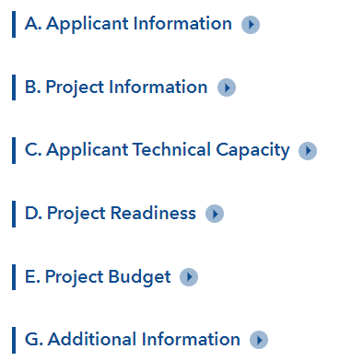

Before you begin filling out the online application, please have all your project information and materials ready. **You will not be able to save your work and continue the online application at a later time**. We suggest filling out this document and transferring the information into the online template after it is complete.

Character limits for open-ended questions are 1,000 characters unless otherwise noted. This equates to about 4-5 sentences.

A red star next to a question denotes that a response is required (as shown below).

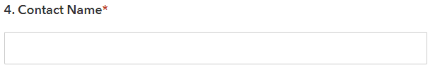

**Project Type**

There are three project types listed in the drop-down menu – Planning, Infrastructure, and Non-Infrastructure. Each project type has differing application questions. For example, information about right-of-way and utilities is only required of infrastructure projects.

**Planning Projects** include the analysis required to develop a firm project scope, schedule, and budget for an eligible capital improvement.

**Infrastructure Projects** include the design or construction of an eligible capital improvement.

**Non-infrastructure** **Projects** include education, outreach, and staffing associated with Safe Routes to School programs.

*This question is required.*

**Please select the project type:**

Choose an item.

**Section A: Applicant Information**

This section requires basic contact information for the applicant. The Unique Entity Identifier (UEI) is required by the federal government for grantees. On April 4, 2022, the federal government stopped using the DUNS number to uniquely identify entities. Now, entities doing business with the federal government must use the Unique Entity ID created in [SAM.gov](https://sam.gov/content/entity-registration).

*All fields in this section are required.*

**1. Sponsor Organization:**

**2. Sponsor Type:** *(select from drop-down box below)*

Choose an item.

**3. Agency Address:**

**4. Contact Name:**

**5. Title:**

**6. Phone:**

**7. Email:**

**8. Unique Entity Identifier (UEI):**

**Section B: Project Information**

This section requests basic information about the project. The Project Information category includes a drop-down list of the eligible projects under each project type. This list is different for infrastructure, planning, and non-infrastructure projects. If your project type is not on the menu of options, it may not be eligible for the TA Set-Aside program. Under project purpose, please briefly describe why this project is important and the needs it is intended to address.

*All fields in this section are required.*

**1. Project Name:**

**2. Eligible Project Category:** *(select from drop-down box below)*

Choose an item.

**3. Project Purpose:**

**4. Project Description:**

**5. Project Location:** *(provide project address and/or project limits)*

The online application includes an interactive mapping tool (shown below) that can be used to draw the extent of your proposed project. For Planning, Non-infrastructure, and expansive Infrastructure projects, draw a large polygon approximating the area of coverage. In some cases, this may be an entire county.   
  
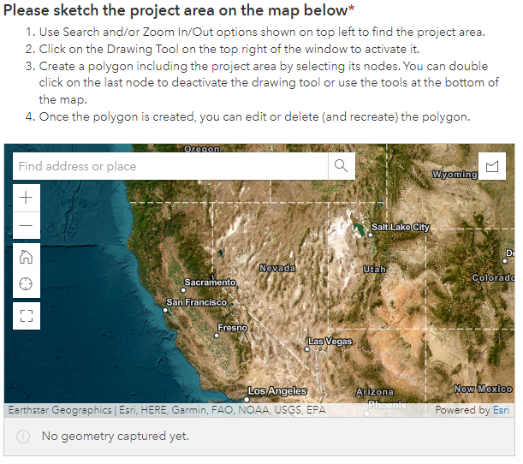

**Section C: Applicant Technical Capacity**

To promote successful project implementation, NDOT provides informational resources about the grant application and administration process. This section is intended to determine whether the application has utilized these resources and identify the staff capacity for administering the grant.

*All fields in this section are required.*

**1. Have you held a pre-application meeting with NDOT?** *(select from drop-down box below)*

Choose an item.

**2. Do you have staff with experience or training administering state or federal grants?**   
 *(select from drop-down box below)*

Choose an item.

**If yes, provide name and position:**

**3. Have you attended/viewed NDOT TA Set Aside training?** *(select from drop-down box below)*

Choose an item.

**Section D: Project Readiness**

Completion of projects on schedule and within budget is a goal of this program. Reviewing the level of project readiness will allow NDOT to determine whether the project is prepared for successful implementation or if additional advance work may be required. The purpose of establishing the planning category is to provide resources for applicants to develop a firm and reliable project scope, schedule, and budget.

The Schedule Milestones question allows applicants to present the planned duration for project completion and timeline for major milestones. The timeline and milestones will vary by project type. For example, milestones for infrastructure projects may include environmental clearance, right-of-way acquisitions, the timeline for preliminary and final design, and construction. Milestones for a planning study may include existing conditions analysis, alternatives evaluation, and refinement of the project delivery schedule and budget.

The check box options under Previous Work are different for the three project types (infrastructure, planning, and non-infrastructure).

*Questions 1, 2, and 5 are required.*

**1. Schedule Milestones:**

**2. Previous Work:**

Planning Study Completed

NEPA Completed

Preliminary Engineering Completed

Final Design Completed

Other (Please specify below)

**Other:**

**3. Please select all choices that apply regarding Right of Way:**

A permanent take of property is needed for the project

A permanent easement is needed (for drainage, maintenance, etc.)

A temporary easement is needed for construction of the project

**4. Please select whichever applies regarding utilities:**

Utility covers needing adjustment

There will be utility relocation(s)

A new power source or power drop is needed

**5. What agency will be responsible for maintenance after completion?**

**Section E: Project Budget**

A clearly defined budget and dedicated funding for the local match requirement are important aspects of project preparedness. A minimum 5% local match is required.

*All fields in this section are required.*

**1. Total Estimated Project Cost?** *(dollar amount)*

**2. Please attach a copy of detailed cost estimate.** Attachment should be one document including Preliminary Engineering costs, Right of Way costs,   
 Construction costs, etc. (Max file size is 100 MB).



**3. Local Match?** *(dollar amount)*

**4. Source of Local Match?**

**5. Requested TA Set Aside Grant Amount?** *(dollar amount)*

**Section F: Project Benefits – Infrastructure Projects**

There are different questions in this section depending on whether you indicated that you are submitting an Infrastructure or a Planning/Non-Infrastructure Project. Planning and Non-Infrastructure Projects have been grouped together in the application because similar types of questions are applicable. Screen shots from both application types are provided below. This section includes a series of yes/no questions that are followed by the opportunity to briefly provide explanatory information and context (i.e., an additional box will pop up upon choosing “Yes”).

The evaluation criteria in this section are tied to the One Nevada goals, as described more fully in the main body of the guidance document. Each yes/no question may be assigned one point. The follow-up questions provide an opportunity for applicants to share additional context or reference information.

*All fields in this section are required.*

**1. Is the project identified in a safety plan?** *(select from drop-down box below)*

Choose an item.

**Please briefly explain if the answer is Yes.** *(1-2 sentences)*

**2. Is the project in a high crash area?** *(select from drop-down box below)*

Choose an item.

**Please briefly explain if the answer is Yes.** *(1-2 sentences)*

**3. Does the project incorpoarte proven safety countermeasures?** *(select from drop-down box below)*

Choose an item.

**Please briefly explain if the answer is Yes.** *(1-2 sentences)*

**4. Does the project improve the functionality of an existing transportation facility?** *(select from drop-down box below)*

Choose an item.

**Please briefly explain if the answer is Yes.** *(1-2 sentences)*

**5. Does the project improve conditions for walking, bicycling, or accessing transit?**   
 *(select from drop-down box below)*

Choose an item.

**Please briefly explain if the answer is Yes.** *(1-2 sentences)*

**6. Does the project support local and use plans or goals?** *(select from drop-down box below)*

Choose an item.

**Please briefly explain if the answer is Yes.** *(1-2 sentences)*

**7. Does the project improve alternatives to driving?** *(select from drop-down box below)*

Choose an item.

**Please briefly explain if the answer is Yes.** *(1-2 sentences)*

**8. Does the project improve connections between communities or to community facilities?**   
 *(select from drop-down box below)*

Choose an item.

**Please briefly explain if the answer is Yes.** *(1-2 sentences)*

**9. Does this project benefit a low-income or underserved community?**   
 *(select from drop-down box below)*

Choose an item.

**Please briefly describe the equity benefit provided by this initiative.** *(1-2 sentences)*

**Additional Information**

This section provides an opportunity to include any additional information you believe will help us evaluate your project. You can include a brief summary of this information along with a supporting attachment. Acceptable file types include pdf, doc, docx, xls, xlsx, pptx, ppt, and txt. The maximum allowable file size is 100 MB.

*The fields in this section are optional.*

**1. Please provide any additional information related to the project:**

**2. Please upload letter(s) of support (if applicable)**

Attachment should be one pdf document including all letters of support. (Max file size is 100 MB)



**3. Please upload additional attachment (if applicable)**

Attachment should be one pdf document. (Max file size is 100 MB)

