Complaint Form – Disability Based Discrimination
Nevada Department of Transportation – External Civil Rights
ADA/504 Program
1263 South Stewart Street
Carson City, NV 89712
Phone: (775) 888-7215; Fax: (775) 888-7235
TTY: (855) 878-6368
Email: ADAProgram@dot.state.nv.us

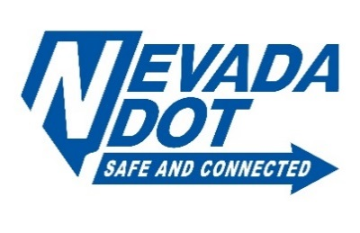

Complainant Information:

Name: First and Last Phone: Phone Number Alternate Phone: Alternate Phone
Mailing Address: Mailing Address City: City State: State Zip Code:
Email: Email Address Today’s Date: 7/30/2026
Preferred method of contact:
☐ Email ☐ Telephone ☐ Mail ☐ Other: Description of other contact method
Nature of complainant disability:
Nature of complainant disability
Incident details:
Date: Date of Incident Time: 00:00
Location (include street name(s) or route number, nearest cross streets, landmarks, facility name, etc.)
Description of the location

Provide a detailed explanation of the accessibility barrier or discrimination:
Detailed explanation of the accessibility barrier

Select each of the following that are applicable to the access barrier or discrimination complaint:
☐ Public Rights-of Way ☐ Program ☐ Service ☐ Activity
Proposed solution to complaint:
Proposed Solution to the complaint

Has any other agency been contacted regarding this request? ☐ Yes ☐ No
If yes, what agency or agencies did you contact? Agency in contact
Who were the agents you spoke with? Agents you spoke with

