Recommendations and Comments Form
Nevada Department of Transportation – External Civil Rights
ADA/504 Program
1263 South Stewart Street
Carson City, NV 89712
Phone: (775) 888-7215; Fax: (775) 888-7235
TTY: (855) 878-6368
Email: ADAProgram@dot.state.nv.us

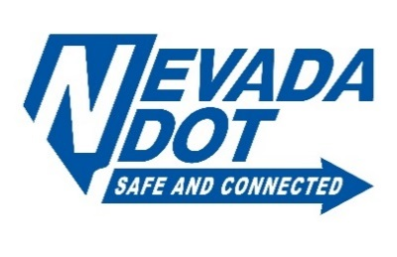

Contact Information:

Name: First and Last Phone: Phone Number Alternate Phone: Alternate Phone
Mailing Address: Mailing Address City: City State: State Zip Code: 00000
Email: Email Address Today’s Date: 7/28/2026
Preferred method of contact:
☐ Email ☐ Telephone ☐ Mail ☐ Other: Description of other contact method
Recommendations:
Please type any recommendations here

Comments:
Please type any comments here

Has any other agency been contacted regarding this request? ☐ Yes ☐ No
If yes, what agency or agencies did you contact? Government or private
Who were the agents you spoke with? Names of agents and phone numbers, if possible

