NDOT ADA Transition Plan Request Form
Nevada Department of Transportation – External Civil Rights
ADA/504 Program
1263 South Stewart Street
Carson City, NV 89712
Phone: (775) 888-7215; Fax: (775) 888-7235
TTY: (855) 878-6368
Email: ADAProgram@dot.state.nv.us

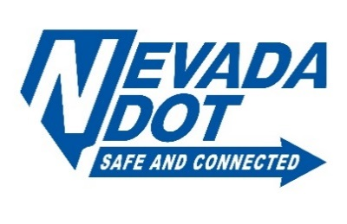

Complainant Information:

Name: First and Last Phone: Phone Number Alternate Phone: Alternate Phone Number
Mailing Address: Mailing Address City: City State: State Zip Code:
Email: Email Address Today’s Date: 7/28/20268/30/2016
Preferred method to have document sent:
☐ Email ☐ Mail ☐ Other: Description of other contact method
Number of copies requested:

Do you require the Transition Plan in a language other than English? ☐ Yes ☐ No

What language do you need the Transition Plan translated to? Language Preference

Do you require large print? ☐ Yes ☐ No

If you have any additional requests or requirements concerning the Transition Plan, please explain below:
Additional Requests

Note: Requests may take up to three business weeks to complete, depending upon the complexity. Our goal is to make sure you get your document sent to you within a timely manner.

